REGIME SWITCHING VOLATILITY PREDICTOR USING MACHINE LEARNING

BY
Data Science Team
Hithesh Reddy
Asad Tafheem
Hari Charan Reddy
Yashraf Khan

TABLE OF CONTENTS

SI NO | CONTENTS |  |  |  |  |  |  |  | PAGE NO
 | ABSTRACT
1 | INTRODUCTION
2 | PROBLEM STATEMENT
3 | SOFTWARE REQUIREMENT SPECIFICATION
 | 3.1 | PURPOSE
 | 3.2 | OBJECTIVES
 | 3.3 | REQUIREMENTS
 |  | 3.3.1 |  |  |  |  |  | SOFTWARE REQUIREMENTS
 |  | 3.3.2 |  |  |  |  |  | HARDWARE REQUIREMENTS
4 | DATASET & METHODOLOGY
 | 4.1 |  | DATASET DESCRIPTION
 | 4.2 |  | DATA COLLECTION
 | 4.3 |  | MACHINE LEARNING MODEL ARCHITECTURE
 | 4.4 |  | MODEL TRAINING
 | 4.5 |  | EVALUATION METRICS
 | 4.6 |  | DEPLOYMENT METHODOLGY
5 | IMPLEMENTATION
 | 5.1 |  |  | SYSTEM IMPLEMENTATION OVERVIEW
 | 5.2 |  |  | MODEL TRAINING IMPLEMENTATION
 | 5.3 |  |  | MODEL EVALUATION
 | 5.4 |  |  | FINALIZED MODEL FOR PREDICTION
 | 5.5 |  |  | PICKLE FILES WE USED
 | 5.6 |  |  | PICKLE FILES
 | 5.7 |  |  | OUTPUT SCREENS
 |  |  |  | 5.7.1 |  |  | HOME PAGE
 |  |  |  | 5.7.2 |  |  | ABOUT PAGE
 |  |  |  | 5.7.3 |  |  | CONTACT PAGE
6 | RESULT ANALYSIS
 | 6.1 |  |  |  | PERFORMANCE EVALUATION
 | 6.2 |  |  |  | ANALYSIS & INSIGHTS
7 | CONCLUSION &FUTURE SCOPE
 | 7.1 |  |  |  |  | CONCLUSION
 | 7.2 |  |  |  |  | FUTURE SCOPE

ABSTRACT
The Regime Switching Volatility Predictor is a machine learning-based system designed to identify and classify stock market conditions into different volatility regimes. Financial markets are highly dynamic and often switch between periods of high volatility and low volatility, which directly impacts investment risk and decision-making.
This project utilizes historical stock market data and applies data preprocessing, feature engineering, and classification techniques to predict volatility regimes. Key features such as daily returns, rolling volatility, and Relative Strength Index (RSI) are extracted to capture market behaviour effectively. A Logistic Regression model is trained on these features to classify the market into high volatility (high risk) and low volatility (low risk) regimes.
The system aims to automate the process of market analysis, reducing dependency on manual interpretation and improving prediction efficiency. It provides quick and reliable insights into market conditions, which can help investors and analysts make informed decisions.

1.INTRODUCTION
The Regime Switching Volatility Predictor is a machine learning-based project developed to analyse and classify stock market conditions into High Risk and Low Risk regimes. Financial markets are highly dynamic and often shift between periods of stability and volatility, making it important to identify these changes accurately for better decision-making.
This project focuses on detecting such regime shifts by using historical stock market data and key technical indicators such as Relative Strength Index (RSI) and rolling volatility. By applying a Logistic Regression model, the system learns patterns from past data and predicts the current market regime based on real-time inputs.
The main objective of this project is to build a simple and efficient predictive system that helps users understand whether the market is in a stable or volatile phase. The integration of live data fetching further enhances the system by enabling real-time predictions for selected stocks.
A key feature of this project is the integration of real-time data using financial APIs, which enables the system to make live predictions based on the most recent market information. This makes the model not only theoretical but also practical and applicable in real-world scenarios.
The ability to anticipate shifts between these regimes represents a significant competitive advantage in quantitative finance. Such predictive capability enables:
- Dynamic Risk Management: Reducing exposure before volatile periods
- Adaptive Asset Allocation: Shifting portfolio weights based on expected market conditions
- Enhanced Trading Strategies: Adjusting position sizing and entry/exit criteria
- Improved Derivative Pricing: Better calibration of options and volatility products
Overall, the Regime Switching Volatility Predictor demonstrates how machine learning techniques can be effectively applied in finance to analyse market behaviour, assess risk levels, and support informed investment decisions.
In conclusion, this project highlights the application of machine learning in the financial domain, demonstrating how predictive analytics can be used to understand market dynamics, detect regime shifts, and assist in developing smarter investment strategies.

2.PROBLEM STATEMENT
Financial markets are highly unpredictable and continuously switch between different conditions such as high volatility and low volatility. These changes, known as regime shifts, make it difficult for investors and analysts to accurately assess market risk and make informed decisions.
Traditional methods of analyzing market volatility rely heavily on manual interpretation of charts and indicators, which can be time-consuming, inconsistent, and less reliable. Moreover, these methods lack the ability to automatically learn from historical data and adapt to changing market patterns.
Due to the absence of an efficient automated system, investors often face challenges in:
- Identifying current market conditions
- Predicting sudden changes in volatility
- Managing investment risk effectively
To address these issues, there is a need for a system that can automatically analyze historical stock data and accurately classify market conditions into high risk (high volatility) and low risk (low volatility) regimes.

3.SOFTWARE REQUIREMENT SPECIFICATION
3.1 Purpose
The purpose of the Regime Switching Volatility Predictor is to develop an intelligent system that can automatically analyze stock market data and identify different volatility regimes. The system aims to reduce the complexity involved in manual market analysis by using machine learning techniques.
It is designed to help users understand whether the market is in a high risk (high volatility) or low risk (low volatility) state. This enables better decision-making for investors, analysts, and financial enthusiasts.
The project also aims to demonstrate the practical application of machine learning in financial forecasting and risk assessment.
3.2 Objectives
- To design and develop a machine learning-based system for predicting market volatility regimes
- To collect and process historical stock market data efficiently
- To implement feature engineering techniques such as returns, RSI, and volatility
- To build a classification model using Logistic Regression
- To classify market conditions into high and low volatility regimes
- To provide quick and accurate predictions
- To reduce manual effort in market analysis
- To improve risk identification and decision-making
- To create a system that can be extended for real-time predictions
3.3 Requirements
3.3.1 Software Requirements
The software requirements for the Regime Switching Volatility Predictor are as follows:
- Operating System: Windows 10/11, Linux, or macOS
- Programming Language: Python
- Development Tools: Jupyter Notebook, VS Code, or PyCharm
- Libraries Used:
- Pandas
- NumPy
- Scikit-learn
- yFinance
- Joblib
- Matplotlib
- Internet connection for fetching real-time stock data

3.3.2 Hardware Requirements
The hardware requirements for the system are minimal and are as follows:
- Processor: Intel i3 or above (i5/i7 recommended)
- RAM: Minimum 4 GB (8 GB recommended)
- Storage: At least 500 MB free space
- System Type: 64-bit system recommended
- Internet connectivity for live data access.

4.DATASET & METHODOLOGY
4.1 Dataset Description
The dataset used in the Regime Switching Volatility Predictor consists of historical stock market data. It includes time-series information that reflects the daily performance of selected stocks.
The data primarily contains financial attributes such as opening price, closing price, highest and lowest prices, and trading volume. From this raw data, additional features like daily returns, rolling volatility, and Relative Strength Index (RSI) are derived to better capture market behavior.
This dataset helps in identifying patterns in market movements and is used to classify the market into high volatility and low volatility regimes.
4.2Data Collection
Source of the Data
The dataset is collected through open sources, which provides historical data.
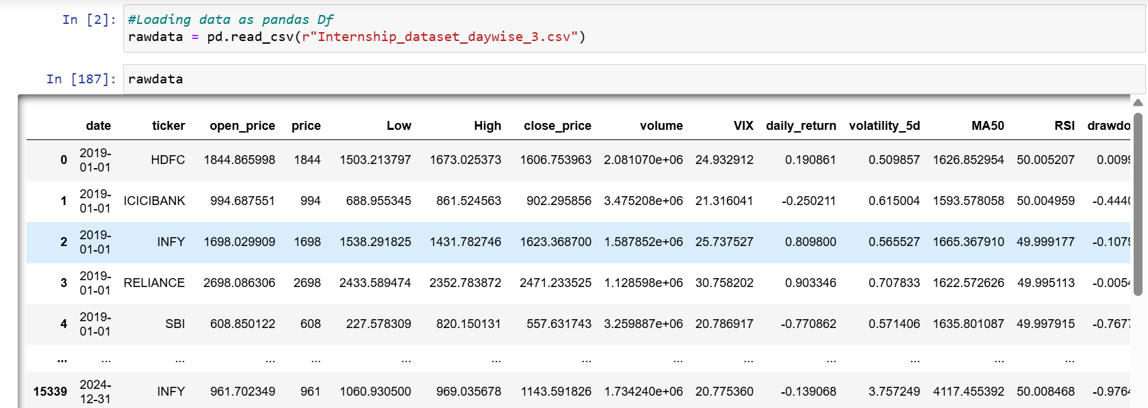
Type of Data Collected
The data collected is:
- Time-Series Data
  - Data recorded over a period of time (daily stock prices)
- Numerical Data
  - Stock prices (Open, High, Low, Close)
  - Trading volume
- Derived Data (Features Created)
  - Daily Returns
  - Rolling Volatility (e.g., 5-day standard deviation)
  - RSI (Relative Strength Index)

Dataset Structure
The dataset used in this project is organized specifically for a classification problem, where the goal is to classify market regimes into High Volatility and Low Volatility.
- The dataset is divided into:
  - Training Set
  - Validation Set
  - Testing Set
- Each dataset contains processed stock market data with features and corresponding labels.
4.3 MODEL ARCHITECTURE
The Regime Switching Volatility Predictor uses a machine learning-based classification approach to identify market regimes.
🔸 Model Used
- Logistic Regression (Supervised Learning Algorithm)
🔸 Architecture Workflow
- Input Layer (Data Input)
  - Historical stock data is provided as input
  - Features include:
    - Returns
    - Volatility
    - RSI
- Feature Processing
  - Data is normalized/cleaned
  - Relevant features are selected
- Model Layer (Logistic Regression)
  - The model learns the relationship between features and target labels
  - It calculates the probability of the market being in:
    - High Volatility
    - Low Volatility
- Output Layer
  - Final prediction is generated:
    - High Risk (High Volatility)
    - Low Risk (Low Volatility)

4.4 Model Training
Model training involves teaching the algorithm to recognize patterns in historical data.
🔸 Steps Involved
- Data is split into:
  - Training set
  - Validation set
  - Testing set
- The Logistic Regression model is trained using:
  - Training dataset
- During training:
  - Model learns relationship between features and target variable
  - Adjusts internal weights to minimize error
- Validation data is used to:
  - Tune model performance
  - Avoid overfitting
4.5 Evaluation metrics
To measure the performance of the model, the following evaluation metrics are used:
🔸 Accuracy
- Measures overall correctness of predictions
🔸 Confusion Matrix
- Shows:
  - True Positives
  - True Negatives
  - False Positives
  - False Negatives
🔸 Precision
- Measures correctness of positive predictions
🔸 Recall
- Measures ability to identify actual positives
🔸 F1-Score
- Harmonic mean of precision and recall

4.6 Deployment Methodology
The deployment phase focuses on making the model usable for real-time predictions.
🔸 Steps Involved
- Model Saving:
  - Trained model is saved using joblib
- User Input:
  - User enters stock ticker symbol
- Data Fetching:
  - Real-time stock data is fetched using API (yfinance)
- Feature Processing:
  - Required features are calculated from live data
- Prediction:
  - Model predicts regime (High / Low)
- Output Display:
  - Final result shown to user as:
    - High Risk
    - Low Risk

5.IMPLEMENTATION
5.1 System Implementation Overview
The Regime Volatility Predictor System is an intelligent machine learning–based solution designed to analyse stock market data and predict market regimes (such as low, High) along with volatility levels. The system leverages historical stock data and advanced predictive models to assist in financial decision-making and risk assessment.
The system integrates trained machine learning models such as Logistic Regression, Random Forest, and other classification algorithms to accurately identify market conditions based on key financial indicators like open price, high, low, volume, and derived features such as returns and moving averages.
For real-time usability, the final model is deployed using the Flask web framework, enabling seamless interaction between the backend and a user-friendly frontend developed with HTML, CSS, and JavaScript. Users can input stock tickers or upload relevant data through the web interface, and the system processes the input to provide instant predictions of market regime and volatility.
This solution is designed to support traders, analysts, and financial institutions by providing quick insights into market behaviour, making it suitable for real-time trading strategies, portfolio management, and risk analysis.

Model Training Implementation
- Load the historical stock market dataset and verify the structure, data types, and time-series consistency for all features.
- Perform data validation and basic cleaning by removing duplicates, handling incorrect values, and ensuring chronological order of stock data.
- Conduct exploratory data analysis (EDA) to understand trends, volatility patterns, correlations, and distribution of key features such as returns, volume, and price movements.
- Handle missing values and outliers using appropriate techniques such as imputation, forward filling, or statistical methods to maintain data integrity.
- Define input features (X) and target variable (y), where the target represents volatility regimes such as Low, Medium, and High.
- Apply feature engineering techniques by generating derived variables such as daily returns, rolling averages, rolling volatility, and technical indicators to improve predictive performance.
- Split the dataset into training and testing sets to evaluate model generalization and avoid overfitting.
- Select suitable machine learning models such as Logistic Regression, Random Forest, or Neural Networks based on the problem requirements.
- Train the selected model using the training dataset while optimizing learning parameters to capture regime-switching patterns effectively.
- Generate predictions on the test dataset and evaluate model performance using metrics such as accuracy, precision, recall, and F1-score.
- Compare multiple models and perform hyperparameter tuning to identify the best-performing model with improved predictive capability.
- Finalize the best model based on evaluation results and robustness across different market conditions.
- Save the trained model along with preprocessing components (scaler, encoders) for future use.
- Deploy the model for real-time prediction by accepting user inputs such as stock ticker and price-related features to predict the current volatility regime.
  - Model Evaluation:
The models were evaluated using accuracy, confusion matrix, ROC curve, and cross-validation methods.
Finally, the best model was Logistic Regression saved and integrated with real-time stock data input to provide practical and reliable day-wise trend predictions.

5.4 Finalized Model for Prediction:
We used Logistic Regression as the final model for prediction.
Logistic Regression is a supervised machine learning algorithm used for classification problems. In this project, it is used to classify stock trends into categories like:
- High
- Low
  - Pickle Files We Used:
In our project, we used pickle (.pkl) files to save and load the trained machine learning model.
- After training the Logistic Regression model, we saved it as a .pkl file
- Later, during prediction, we loaded the model directly from the pickle file
- This helps in making fast and real-time predictions
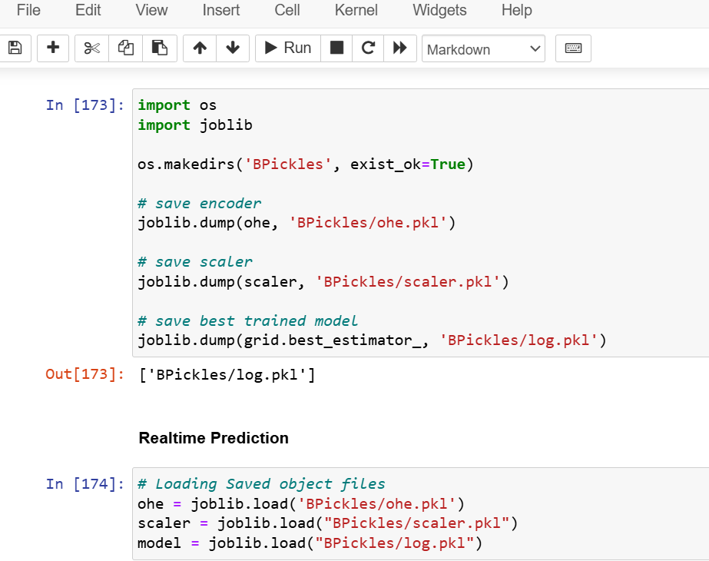
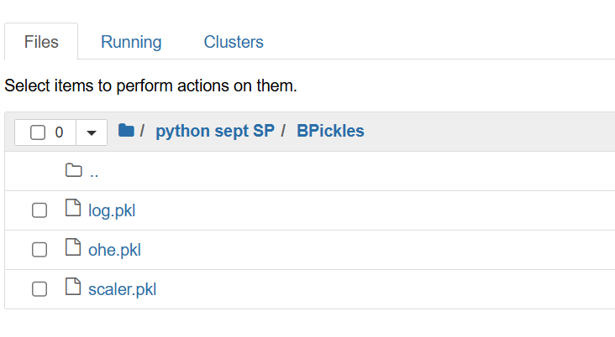
5.6 Pickle Files:

  - Output Screens
Predicting High:
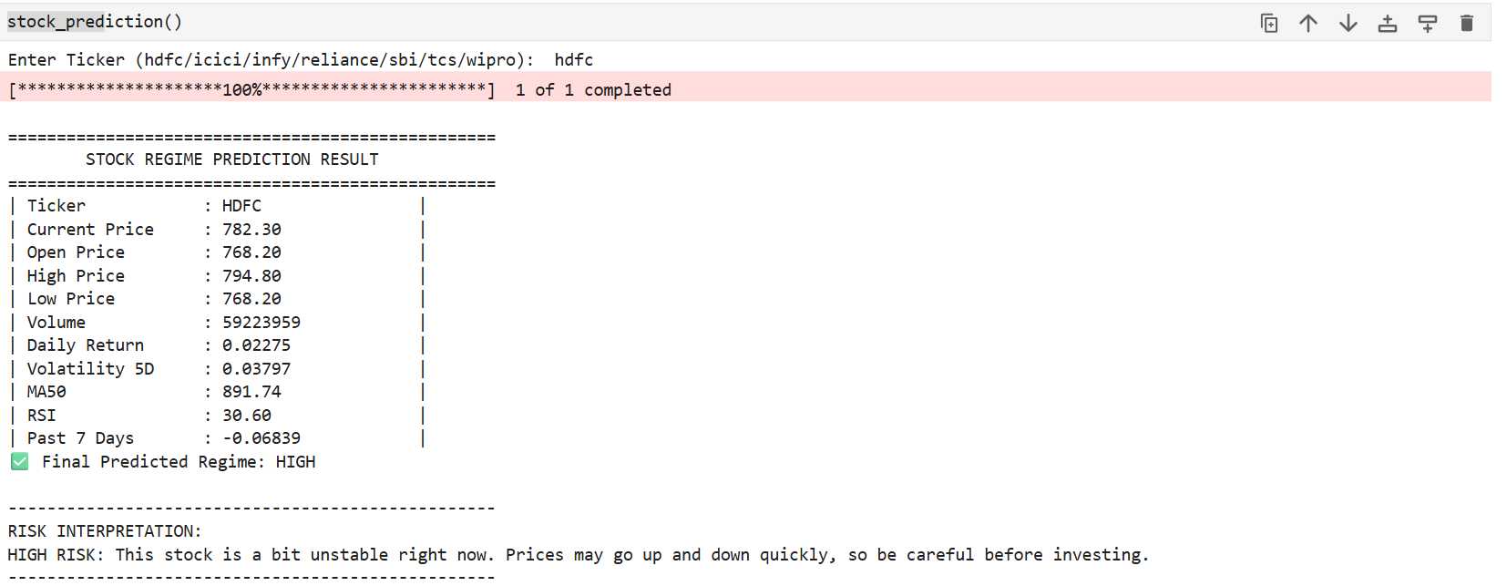
Predicting Low:
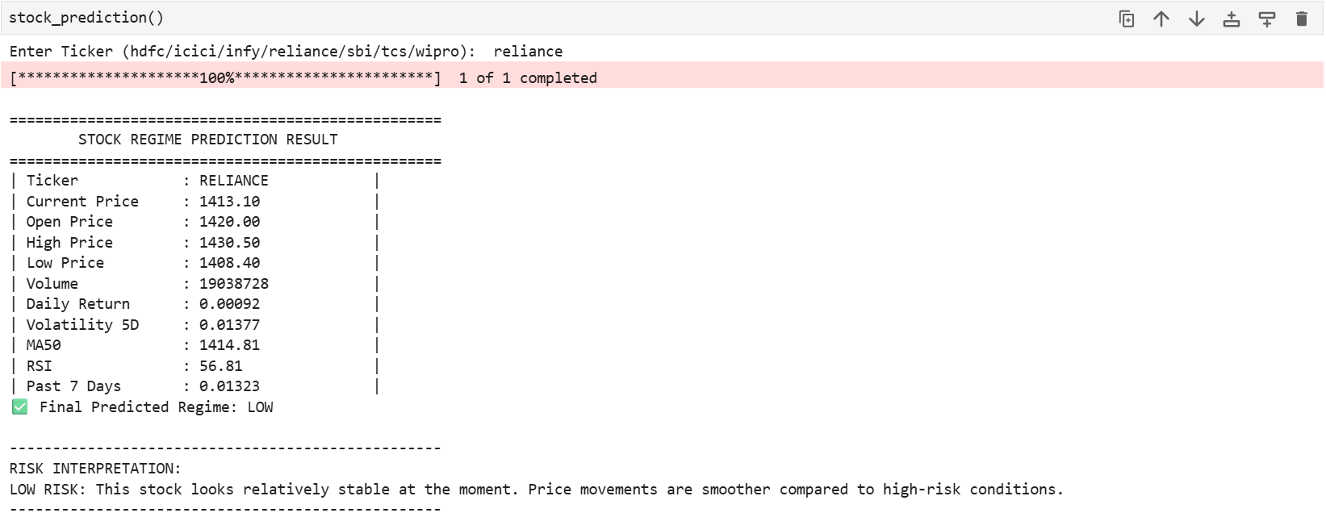

6. RESULT ANALYSIS

6.1 Performance Evaluation
- The regime switching volatility model is evaluated using a separate test dataset to ensure unbiased performance assessment.
- Performance is measured using Accuracy, Precision, Recall, and F1-Score to evaluate classification of volatility regimes (Low, Medium, High).
- The model demonstrates good accuracy in identifying different market volatility conditions and regime transitions.
- The evaluation confirms that the system is reliable and suitable for real-time stock market volatility prediction.

Analysis & Insights
- The machine learning model effectively identifies different market volatility regimes with good accuracy and consistency.
- The model captures dynamic market behaviour and regime shifts, enabling timely identification of changing volatility conditions.
- Feature engineering and preprocessing significantly improve the model’s ability to generalize across different market scenarios.
- The system reduces manual analysis effort and supports faster, data-driven decision-
making in financial markets.

7.CONCLUSION & FUTURE SCOPE

7.1 Conclusion
The proposed Regime Switching Volatility Predictor successfully analyses stock market data using machine learning techniques to identify different volatility regimes. The system accurately classifies market conditions such as low, medium, and high volatility with reliable performance. Integration with a web-based application enables a user-friendly interface for real-time predictions and easy interaction. Overall, the system enhances decision-making by providing faster, data-driven insights into market behaviour, improving efficiency and analytical accuracy in financial forecasting.

7.2 Future Scope
The system can be further enhanced by integrating advanced deep learning models such as LSTM and Transformer-based architectures to better capture time-series dependencies in stock data. Incorporating real-time data streaming and news sentiment analysis can improve prediction accuracy and responsiveness to market events. The model can also be extended to support multiple financial instruments such as commodities, forex, and cryptocurrencies. Additionally, deploying the system on cloud platforms with scalable architecture and improving the user interface with advanced analytics dashboards can make the solution more robust and suitable for large-scale financial applications.

